# Platform game tutorial

Contents

Platform game tutorial 1

1. Gravity 1

2. Add acceleration 1

3. Fix the ground slide bug 2

4. movement – left and right 3

5. Custom Block for Walking: 3

6. Maximum height for walls 4

7. Jumping 4

8. Ceilings 5

9. Add a hitbox 6

## 1. Gravity

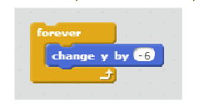

Gravity reduces your “Y”. However this gravity isn’t realistic..

## 2. Add acceleration

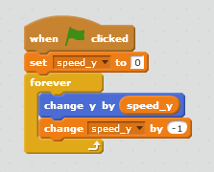

Your speed keeps increasing forever.. we need a ground!



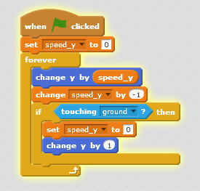

This works great, but you can see him come up out of the ground..

## 3. Fix the ground slide bug

Let’s change to a block so we have instant updates!

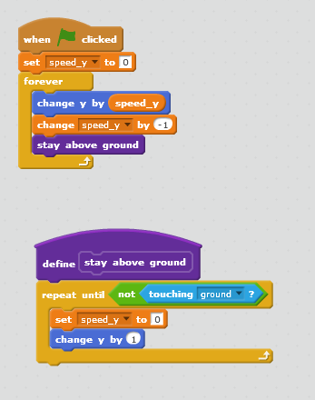

Remember to click “run without screen refresh!”

## 4. movement – left and right

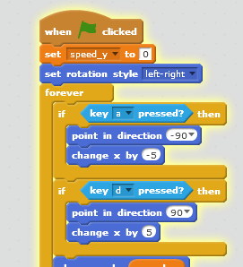

## 5. Custom Block for Walking:

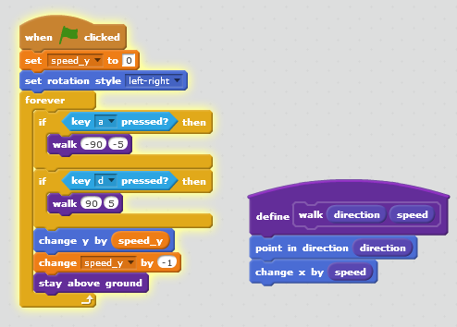

## 6. Maximum height for walls

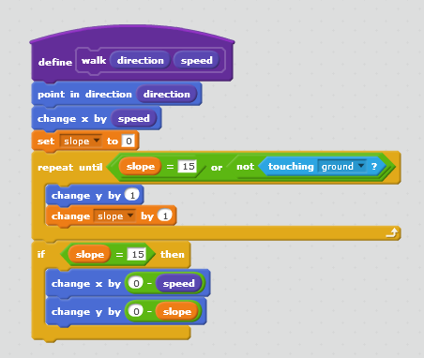

## 7. Jumping

Easy way!

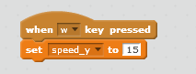

Better.. to avoid the double hops create a variable called “height above ground” that gets bigger when I’m not touching the ground. Only let the jump button work if this is small enough that you might be touching the ground.

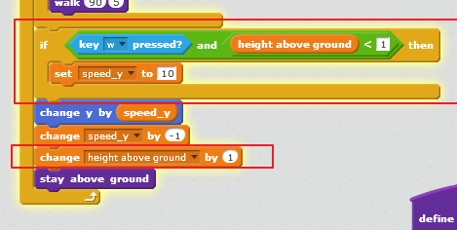

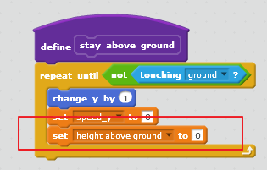

## 8. Ceilings

Ceilings! We do the same as we do for falling, except we move the other way..

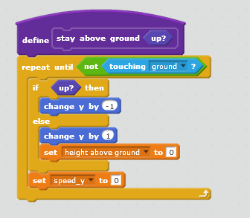



## 9. Add a hitbox

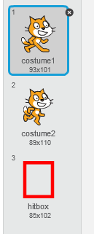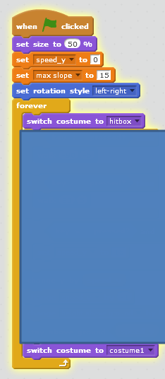

Full Script:

